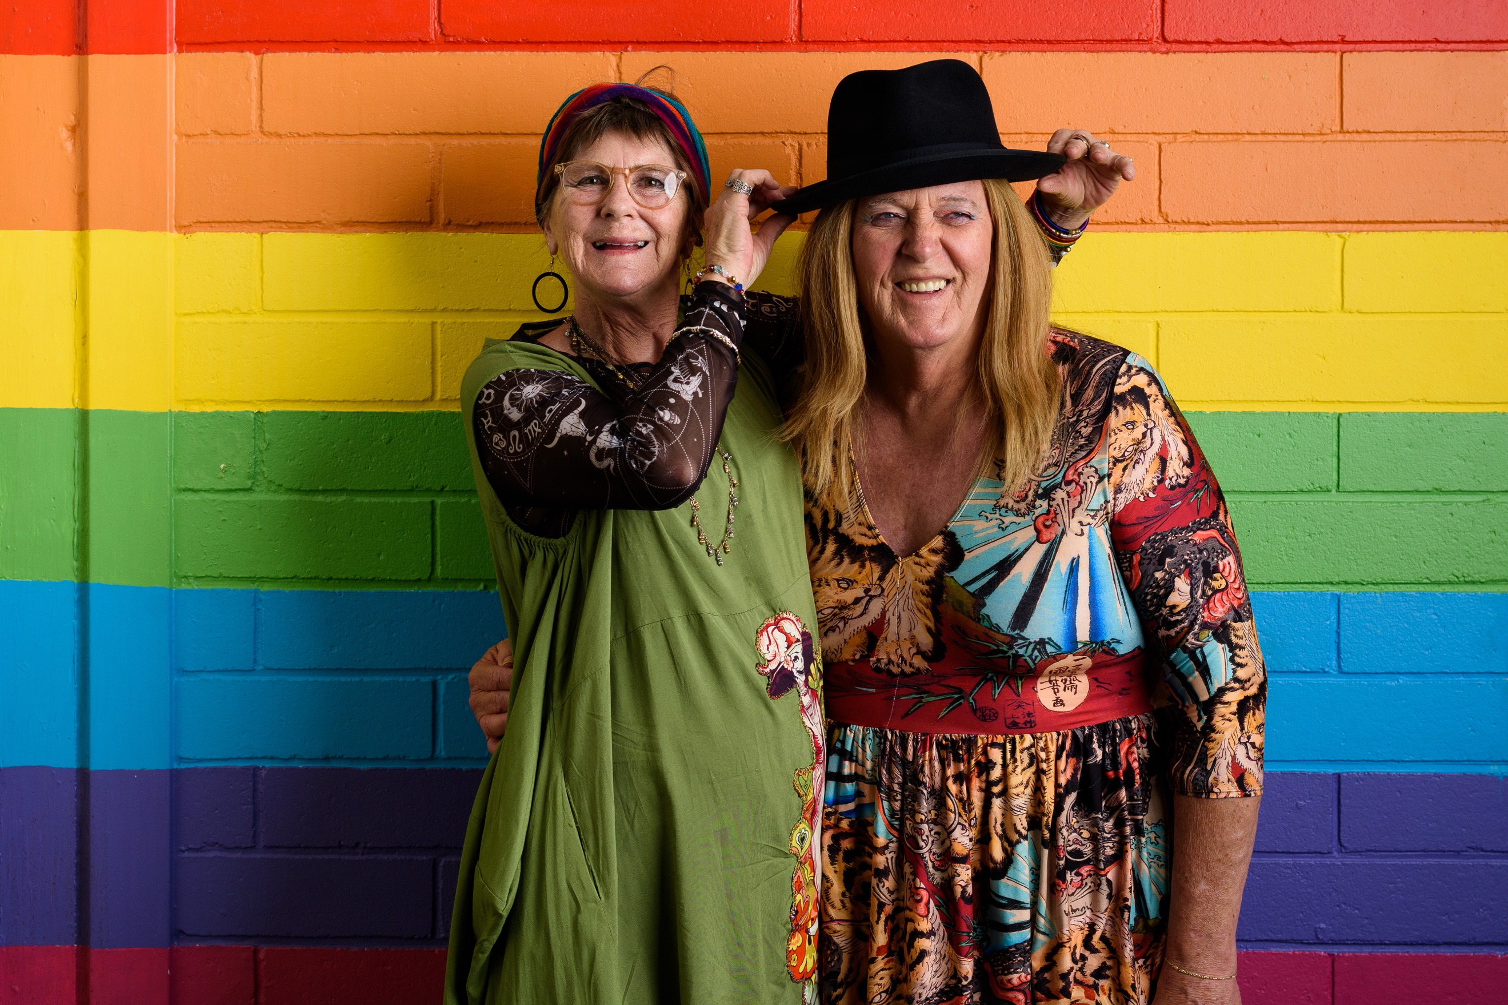

Media Release – 30th May 2023

New Podcast to help prevent Family Violence/Elder Abuse
Experienced by Older LGBTI Australians

On 1st June 2023 a World First Podcast will share family stories of kindness and compassion towards older LGBTI Australians who come out or transition late. The podcast highlights families who are supportive – to help build cultures of respect in families and to prevent Family Violence and Elder Abuse. Project Coordinator Dr Catherine Barrett said:

Some families go for half a century before a rainbow appears, or an older person comes out or transitions. Families may struggle to adapt and this can lead to restrictions on the older LGBTI person’s sexuality or gender expression by their family. Some older LGBTI people find themselves forced to choose between their authentic self and their family. That’s such a difficult position to be in. Family support is critical to ageing with Pride.

We want to support older LGBTI people and their families by profiling stories of how supportive families adapted to change.

The launch of the first episode of There’s a Rainbow in My Family coincides with World Pride Month. Barrett hopes the podcast will be picked up by family violence, elder abuse and aged care services who need to understand the unique challenges for older LGBTI people and support them. Barrett says

There is still not a good understanding of the ways that disrespecting older LGBTI people’s sexuality and gender are forms of elder abuse and family violence – the impacts on the older person are devastating. This podcast is a step towards primary prevention.

The podcast is an initiative of Celebrate Ageing’s Centre for Intergenerational Power. More information call Dr Catherine Barrett on 0429 582 237.
Webpage: https://www.celebrateageing.com/rainbows.html

